Chapter 8, Problem 27.

A branch voltage in an RLC circuit is described by

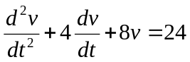

If the initial conditions are v(0) = 0 = dv(0)/dt, find v(t).

